ABOUT US | TENTANG KITA

Established on March 30,2015 with corporate name PT. Freed Dinamika Indonesia and is licensed as Reinsurance Brokers & Consultants by the Board of Commissioners of Otoritas Jasa Keuangan Board of Commissioners license number KEP-524/NB.1/2015.  The initiative behind its formation was basically a genuine spirit to respond to the rapid national economic and industrial development that demanded for dynamic insurance solution and speedy risk distribution locally and internationally, while keeping the common objective of national capacity optimalization.  FreedRe is committed to delivering reliable concepts of risk solutions toward clients, combined with the ultimate objectives of efficiency and competitiveness. FreedRe is always open to strategically synergize with domestic insurers, reinsurers and international markets. We respond to the active demand of multinational industries and corporations for specific insurance and reinsurance solutions.  To realize its objectives, Freed Re serves and maintains an extensive network of potential clients. We invest in a good relationship and in solid cooperation with our working partners of insurers, reinsurers, local and overseas in conventional reinsurance and takaful/syariah, treaty and Facultative cooperation. | Didirikan pada tanggal 30 Maret 2015 dengan nama perusahaan PT. Freed Dinamika Indonesia dan mendapat ijin usaha sebagai Reinsurance Brokers & Consultants dari Otoritas Jasa Keuangan berdasarkan Surat Keputusan Dewan Komisioner Nomor : KEP-524/NB.1/2015.  Gagasan yang mendasari pendiriannya semata-mata adalah semangat keinginan untuk ikut serta menjawab pertumbuhan pesat perekonomian nasional dan perkembangan industri di berbagai bidang yang menuntut solusi-solusi asuransi yang dinamis dan penyebaran risiko yang cepat di dalam negeri maupun di pasar dengan tetap mendukung tujuan bersama optimalisasi kapasitas nasional.  FreedRe berkomitmen untuk menyampaikan konsep-konsep solusi berbagai risiko yang handal kepada seluruh Pelanggan dengan mempertimbangkan tujuan akhir efisien dan daya saing. FreedRe selalu terbuka untuk bersinergi strategis dengan perusahaan-perusahaan asuransi di dalam negeri,perusahaan reasuransi dan pasar internasional. Kami menjawab tuntutan aktif korporasi dan industri multi-nasional terhadap kebutuhan asuransi yang spesifik dan solusi-solusi reasuransinya.  Untuk mewujudkan tujuan-tujuan tersebut,Freed Re memberi layanan dan mempertahankan jaringan luas para Pelanggan potensial. Kami membangun hubungan baik dan kerjasama erat dengan seluruh mitra kerjasama - perusahaan asuransi, Perusahaan reasuransi dalam dan luar negeri dalam kerjasama reasuransi konvensional dan takaful/syariah, Treaty maupun Facultative.
LICENSE

Otoritas Jasa Keuangan (Indonesia Financial Services Authority)
Number: KEP-5524/NB.1/2015
INSURANCE BROKERS ASSOCIATION MEMBERSHIP
APPARINDO Registration No:217-2015/APPARINDO/2015

MANAGEMENT TEAM

BOARD OF COMMISSIONERS

Muhammad Amin Anggiato Irjen Pol. (Purn) Drs. Harry Montolalu, MM
President Commissioner Commissioner

BOARD OF DIRECTORS

Hendrik S. Nadapdap MM. LUF. APAI Ir. Agus Prianto, AAAIK., CIIB
CEO & President Director Director

TEAM

BROKING
Fernando Tamba (Manager)
Leonardo Hutajulu (Manager)

TECHNIC

Yulia Tiurina (Associate Director)
Andita Pratiwi (Manager)
Abdul Rozak (Sr. Account Executive)
Ganda Rino Daniel Aritonang (Claim)

ACCOUNTING & FINANCE
Gyna Kusumadewi (Manager)
Tengku Nazri Zumairi (Finance)
Gamar Puspitasari (Finance)

VISION & MISSION  THE VISION  Aimed at being a private national reinsurance broker with value added and excellent reinsurance services and solutions ensuring long term beneficial cooperation  THE MISSION  - Listen and understand Clients needs  - Review and propose solutions  - Deliver solutions and perform cooperation  - Keep to serve and cooperate at best  - Consistent to long-term beneficial cooperation.  CORPORATE CULTURE  - Customer Orientation  - Professionalism  - Integrity  - Synergized partnership  - Continuous improvement of competency and performance  BEHAVIOURAL VALUES  Sincerity, Creativity & Innovation | VISI & MISI  VISI  Bertujuan menjadi broker reasuransi swasta nasional dengan nilai tambah dan keunggulan dalam kualitas layanan dan solusi reasuransi dan memastikan kerjasama menguntungkan jangka panjang  MISI  - Mendengarkan dan memahami kebutuhan Klien  - Mengulas dan merancang solusi  - Menyampaikan dan melaksanakan Kerjasama  - Melayani dan bekerjasama sebaik-baiknya  - Konsisten untuk kerjasama saling menguntungkan jangka panjang.  BUDAYA KERJA  - Orientasi pada kebutuhan Konsumen  - Profesionalisme  - Integritas  - Kemitraan bersinergi  - Peningkatan kompetensi dan kinerja berkesinambungan  NILAI PERILAKU  Santun, Kreatif & Inovatif

AREA OF BUSINESS  Freed Re dedicates itself to provide clients with reinsurance arrangements for the protection of their assets, interests, and liabilities. We strive to assist you in supporting toward efficient and competitive corporation.  Our team of qualified entrepreneurial professionals is ready to work with you and in the interest of the insured and insurers, to negotiate the best reinsurance programs available in the market. We deal with the reinsurance schemes of almost all insurance products. | BIDANG USAHA  Freed Re mendedikasikan untuk menyediakan pengaturan asuransi dan reasuransi bagi klien guna melindungi aset, kepentingan dan tanggung-gugat. Kami berusaha membantu Anda dalam mendukung korporasi yang efisien dan berdaya saing.  Tim kami para profesional berkualifikasi dan kewirausahaan siap bekerjasama dengan Anda dan berada di pihak Tertanggung dan Penanggung, untuk merundingkan program reasuransi terbaik dari yang ada di pasar. Kami menangani skema-skema reasuransi untuk hamper seluruh jenis produk asuransi.

EXPERIENCE

- Arranged Aviation Treaty for Reinsurance Company
- Arranged Marine Hull Prop. & Non Prop. Treaty for Insurance Company
- Arranged MOP Cargo for Insurance Company
- Arranged Facultative Retro Aviation and Marine Hull
- Arranged Facultative Business

TREATY  Proportional Reinsurance  Non-Proportional / Excess of Loss  Risk Excess of Loss (Layered basis)  Aggregate & Stop Loss Cover  RETAKAFUL  Proportional and Non Proportional Treaty design and negotiation,  All clases of Facultative syariah reinsurances. | SPECIAL FACILITY  Open Cover, Binders, Umbrella and Catastrophe covers.  FACULTATIVE  Property All Risks, Industrial All Risks, Business Interruption;  Erection, Engineering, Construction;  Marine Hull, Marine Cargo and Sea Ports & Terminals;  Aviation Hull & Liability, Airports Operators Liability;  General Liability, Casualty, Professional Indemnity, Directors & Officers Liability;  Accident & Health, Political Risks, Sabotage & Terrorism;

We help you reinsure major risks  Kami membantu Anda mereasuransikan risiko-risiko besar | FreedRe welcomes strategic cooperation with direct brokers and underwriters to serve in providing major classes of insurance and reinsurances | FreedRe bersedia bekerjasama strategis dengan pialang asuransi dan para underwriter untuk membantu dalam menyediakan asuransi dan reasuransi atas risiko-risiko besar.
PROPERTY /PROPERTI   | FreedRe are committed to handle major property business of energy, industry, construction and transportation. We actively assist in the review toward achieving efficient and effective risk solutions available the local and international market. | FreedRe siap menangani bisnis properti seperti energy industry,konstruksi dan transportasi. Kami aktif membantu dalam peninjauan dalam rangka mengusahakan solusi-solusi risiko yang efektif dan efisien yang tersedia di pasar lokal dan internasional.
MARINE/ LAUT   | FreedRe fully understands the developing maritime sector where maritime related activities and infrastructure development demands for specific and yet efficient insurance and reinsurance coverage. We intensively work with partners in actualizing role to contribute to the maritime development | FreedRe sangat mengerti pertumbuhan sektor kemaritiman dimana kegiatan pembangunan sarana dan prasarananya memerlukan dukungan asuransi dan reasuransi yang spesifik dan tetap efisien. Kami secara intensif bekerja dengan mitra-usaha untuk menyuguhkan peran dalam mendukung pembangunan kelautan.
AVIATION/ PENERBANGAN   | FreedRe views that air transportation has become vital and will remain so in the future that consequently Insurance of its sophisticated risks must be in full service. We will participate in looking for as best insurance/reinsurance solutions to this sector. | FreedRe memahami bahwa transportasi udara merupakan hal vital dan terus demikian di masa depan sehingga asuransi harus selalu tersedia bagi risiko canggih ini. Kami akan ikut serta dalam mengusahakan solusi asuransi/reasuransi yang terbaik bagi sektor ini.
INSURANCE OF THE PERSON   | FreedRe take care of this primarily life related risks. We assist in helping direct insurance brokers and their clients in designing the most appropriate insurance program for Group Life, Personal Accident, Travel Insurance, Credit Life and Employee Benefit schemes for industrial client. | FreedRe mengurus risiko-risiko terkait dengan jiwa/kehidupan. Kami memberikan asistensi kepada pialang asuransi dan Kliennya dalam merancang program terbaik bagi asuransi Jiwa Kumpulan, Kecelakaan Diri Perjalanan, Jiwa Kredit dan skema Jaminan Karyawan bagi Klien-klien pelaku industri.
NEW BUSINESS INITIAVES   | FreedRe continuously look for acquiring information and knowledge on new products, coverages and technologies that would be appropriate,viable and demanded for. We contribute to accelerate the insurance industry development. | FreedRe terus berusaha mendapatkan informasi dan pengetahuan tentang produk asuransi, jaminan dan teknologinya yang cocok, layak terapan dan dibutuhkan. Kami menyokong percepatan bagi perkembangan industri asuransi.

FREED RE ROLE & FUNCTION | PERAN & FUNGSI FREED RE
FREEDRE help handle your risks  FREEDRE provides risk management consultation from the reinsurance side working together with direct Insurers and direct insurance brokers.  FREEDRE place your reinsurance  FREEDRE through its internal security committee will select Reinsurance Companies of excellent financial standing and security level  FREEDRE deal with your reinsurance claims  FREEDRE is on your side to deal with your claim to ensure it is given prompt assessment referring to reinsurance policy terms and settled satisfactorily and in timely manner. | FREEDRE Membantu menangani risiko Anda  FREEDRE menyediakan konsultasi manajemen risiko dari sisi reasuransi bekerjasama dengan Perusahaan Asuransi dan Pialang Asuransi  FREEDRE Menempatkan Reasuransi Anda  FREEDRE melalui komite sekuriti internal akan memilih Perusahaan Reasuransi dengan kesehatan keuangan dan peringkat keamanan yang baik  FREEDRE Mengurus Klaim Reasuransi Anda  FREEDRE berada di pihak Anda untuk mengurus klaim, memastikan secepatnya diases merujuk ketentuan dan persyaratan perjanjian reasuransi dan selesaikan secara tepat waktu dan memuaskan.

FINANCIAL HIGHLIGHT

OUR CLIENTS
KLIEN-KLIEN KAMI

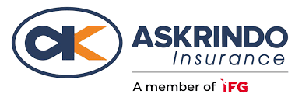
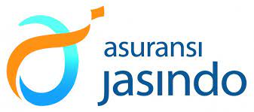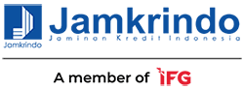
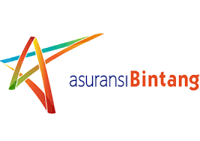
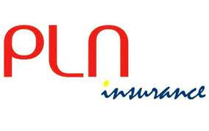
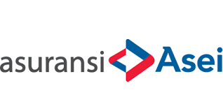

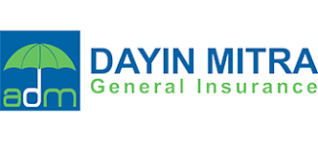

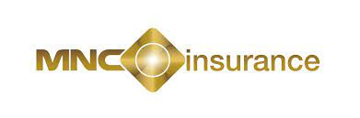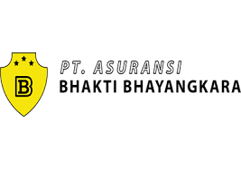

CONTACT US
Apartment Sahid Sudirman Residence Office Lt.1 Unit 05,
Jl. Jenderal Sudirman Kav.86 Jakarta 10220, INDONESIA
P : +62 21 29022797
F : +62 21 29022737
E : info@freedre.com

